Project Report: PhonePe Transaction Insights
Project Type: Exploratory Data Analysis (EDA) & Data Engineering
Live Dashboard: Streamlit Web App
GitHub Repository: Source Code

1: Executive Summary & Business Objective
Executive Summary
The rapid proliferation of digital payment systems has fundamentally transformed the financial landscape in India. PhonePe, as a market leader in this domain, facilitates millions of transactions daily, generating a massive and complex trail of data. The "PhonePe Transaction Insights" project is designed to harness this extensive dataset—specifically the PhonePe Pulse data—to decode underlying transaction dynamics, user engagement patterns, and the adoption of emerging financial services like insurance. The core objective of this project was to build an end-to-end data pipeline that extracts, processes, and visualizes these metrics to empower data-driven strategic decision-making.
Methodologically, this project follows a rigorous Extract, Transform, and Load (ETL) framework. Raw data, initially nested in complex JSON structures across multiple directories in the PhonePe GitHub repository, was programmatically parsed using Python. This data was categorized into aggregated metrics, geographical map data, and top-tier leaderboards encompassing transactions, users, and insurance metrics. The transformed data was then systematically loaded into a structured SQLite relational database, enabling highly efficient, complex querying. To make these insights accessible, an interactive Streamlit dashboard was developed, utilizing Plotly to render dynamic, real-time visualizations of the database queries.

Business Objective
The primary business objective is to leverage data-driven insights to optimize user engagement, identify geographical expansion opportunities, and drive strategic product development. Specifically, this analysis aims to:
- Analyze Transaction Behavior: Understand the dominance of payment categories to identify high-revenue streams.
- Map Regional Performance: Pinpoint top-performing and underperforming districts to guide targeted marketing.
- Evaluate User Engagement: Segment the user base by device preferences and app usage frequency to direct technical optimization.
- Assess Insurance Penetration: Track the adoption rates of newly launched insurance products to identify untapped markets.

2: Methodology (ETL Process)
To handle the massive scale of the PhonePe Pulse dataset, a robust ETL (Extract, Transform, Load) pipeline was constructed using Python (data_extraction.py).
- Extract: The raw data was cloned from the official PhonePe Pulse GitHub repository. The data was stored in highly nested JSON files organized by year, quarter, and state. Python's os and json libraries were used to iterate through these nested directories.
- Transform: Using pandas, the extracted JSON data was flattened and structured into 9 distinct DataFrames. This step handled data cleaning, such as formatting state and district names for consistency.
- Load: Finally, the sqlite3 library was utilized to establish a connection to a local database (phonepe_pulse.db). The 9 DataFrames were pushed into 9 separate SQL tables (Aggregated, Map, and Top tables for Transactions, Users, and Insurance).
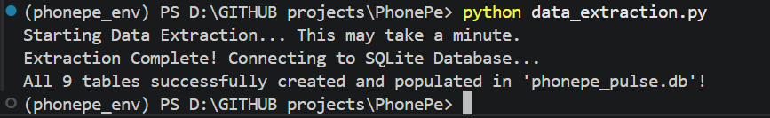

3: Business Insights & Visualizations
Through Exploratory Data Analysis (EDA) of 15 unique charts, several critical market realities emerged. Below are the findings organized into 5 core Business Case Studies.
Business Case 1: Decoding Transaction Dynamics
Scenario: Understanding transaction behavior across different payment categories to drive targeted strategies.
- Findings: Analysis reveals that Peer-to-Peer (P2P) and Merchant payments form the absolute backbone of the platform. Merchant payments account for the highest transaction volume (55.4%), indicating deep integration into daily retail commerce. P2P transfers closely follow, driving the highest overall transaction value. However, high-margin categories like "Financial Services" and "Others" show minimal contribution and stagnant growth over time.
- Business Impact: While the strong adoption of P2P and Merchant payments indicates excellent platform health, the lack of diversification is a risk. PhonePe has a massive opportunity to monetize its existing user base by cross-selling financial services (loans, mutual funds).
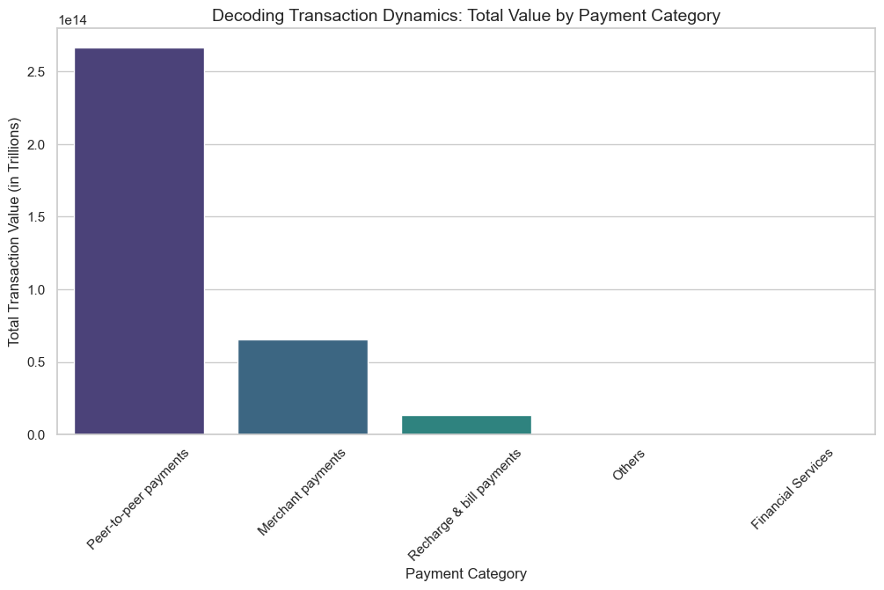

Business Case 2: Device Dominance and User Engagement
Scenario: Analyzing user preferences across device brands to enhance app performance and marketing ROI.
- Findings: PhonePe’s user base is overwhelmingly driven by the Android ecosystem. Xiaomi leads the market share at 25.7%, followed by Samsung (19.9%) and Vivo (18.5%). Apple users constitute a very small minority (~2.8%).
- Business Impact: Product development teams must prioritize Android optimization, particularly for mid-range devices from Xiaomi and Vivo, ensuring the app remains lightweight and fast. The low iOS share indicates weaker penetration in the premium user segment.
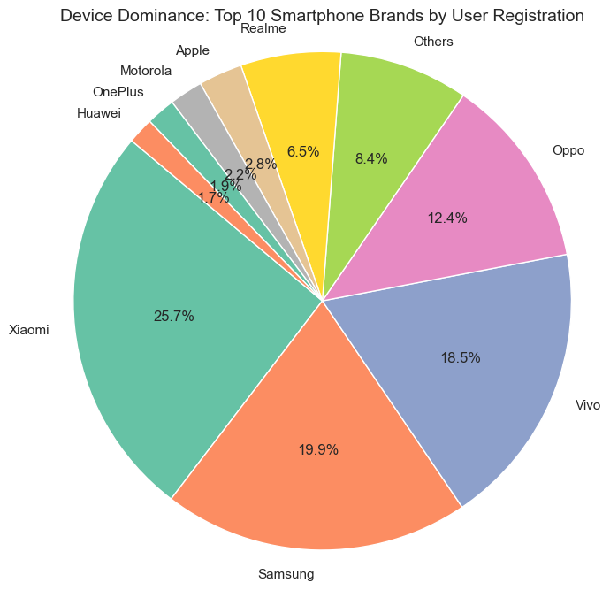

Business Case 3: Insurance Penetration and Growth Potential
Scenario: Analyzing the growth trajectory of PhonePe's newly launched insurance domain at the state level.
- Findings: The insurance segment has shown explosive, sustained growth in premium collections from 2020 to 2024. Geographically, adoption is heavily skewed toward southern and western states, with Karnataka and Maharashtra leading significantly. Northern states, such as Delhi and Rajasthan, exhibit much lower penetration rates despite having large populations.
- Business Impact: The business should capitalize on the established trust in Karnataka and Maharashtra by upselling premium insurance packages. For underperforming northern regions, localized educational campaigns are needed to build awareness.
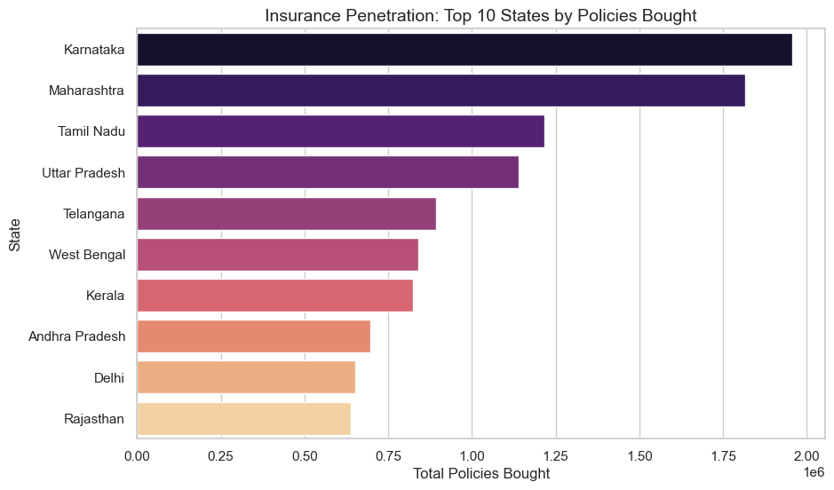

Business Case 4: Transaction Analysis for Market Expansion
Scenario: Identifying top-performing and underperforming geographical areas to optimize expansion efforts.
- Findings: There is a stark digital divide in transaction volumes. Tier-1 urban districts—specifically Bengaluru Urban, Hyderabad, and Pune—dominate the platform's transaction value. Conversely, rural districts (such as Nuiland and Tseminyu) report incredibly low transaction values, highlighting a lack of penetration.
- Business Impact: Maintaining dominance in Tier-1 cities is crucial for reliable revenue. However, to scale further, targeted investment, agent-led onboarding, and low-bandwidth app optimizations are required to capture the untapped rural markets.
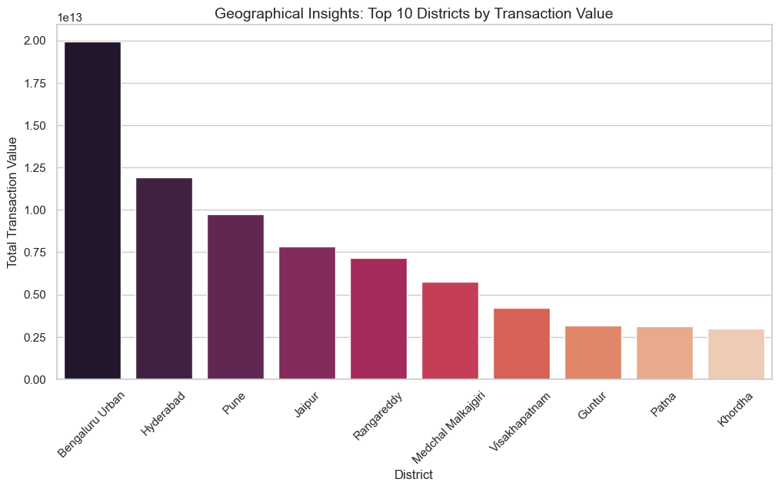

Business Case 5: User Registration vs. Actual Engagement
Scenario: Evaluating whether registered users are actively opening and engaging with the application.
- Findings: A correlation heatmap and scatter plot analysis revealed a moderate correlation (0.61) between total registered users and actual app opens. Furthermore, while registered user growth was rapid until 2021, a sharp drop was observed in 2022.
- Business Impact: This discrepancy indicates that a significant portion of the user base is dormant or engages infrequently. The strategic focus must shift from pure user acquisition to user retention and activation through personalized push notifications and loyalty rewards.
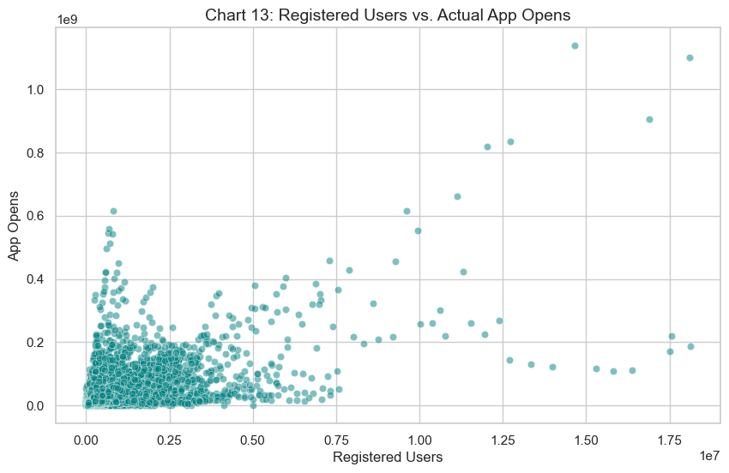
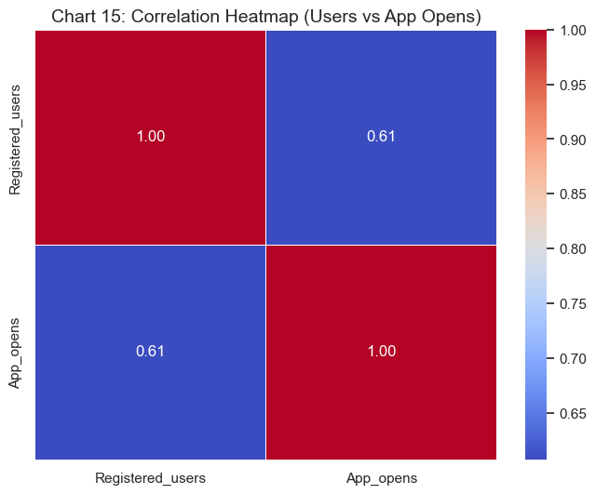

Section 4: Dashboard Deployment (Streamlit)
To make the insights derived from the SQL database accessible and actionable for stakeholders, an interactive web application was developed using Streamlit and deployed via Streamlit Community Cloud.
The dashboard features interactive sidebar filters allowing users to slice the data dynamically by Year, Quarter, and State. Plotly Express was utilized to render real-time, high-quality visualizations (bar charts, pie charts) directly linked to the SQL backend. This deployment ensures that business teams have a live, scalable tool to monitor platform health and regional metrics without needing to write code.
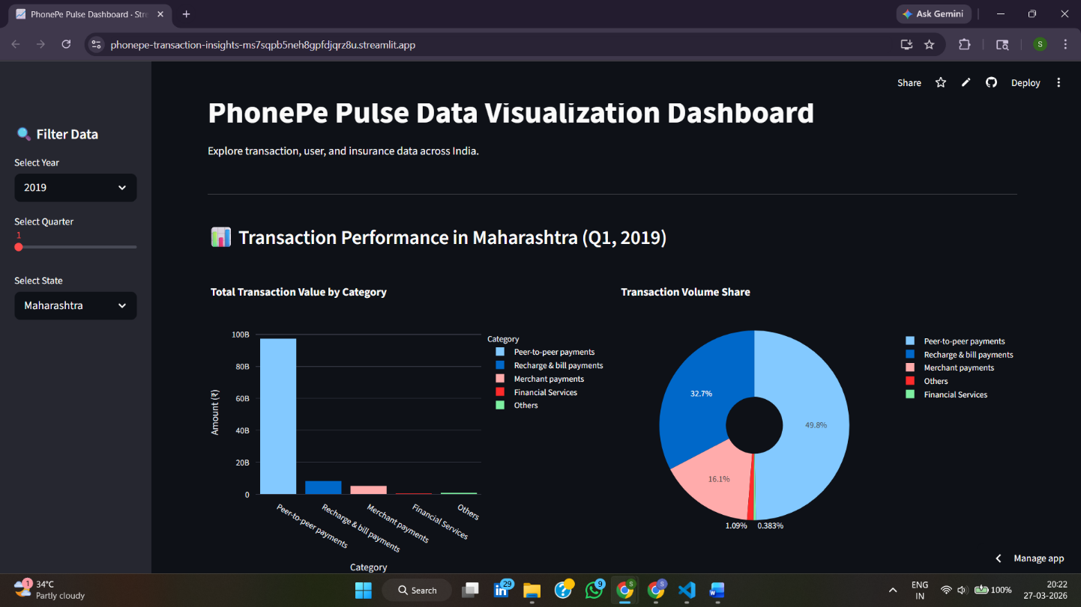
Live Application Link: PhonePe Dashboard
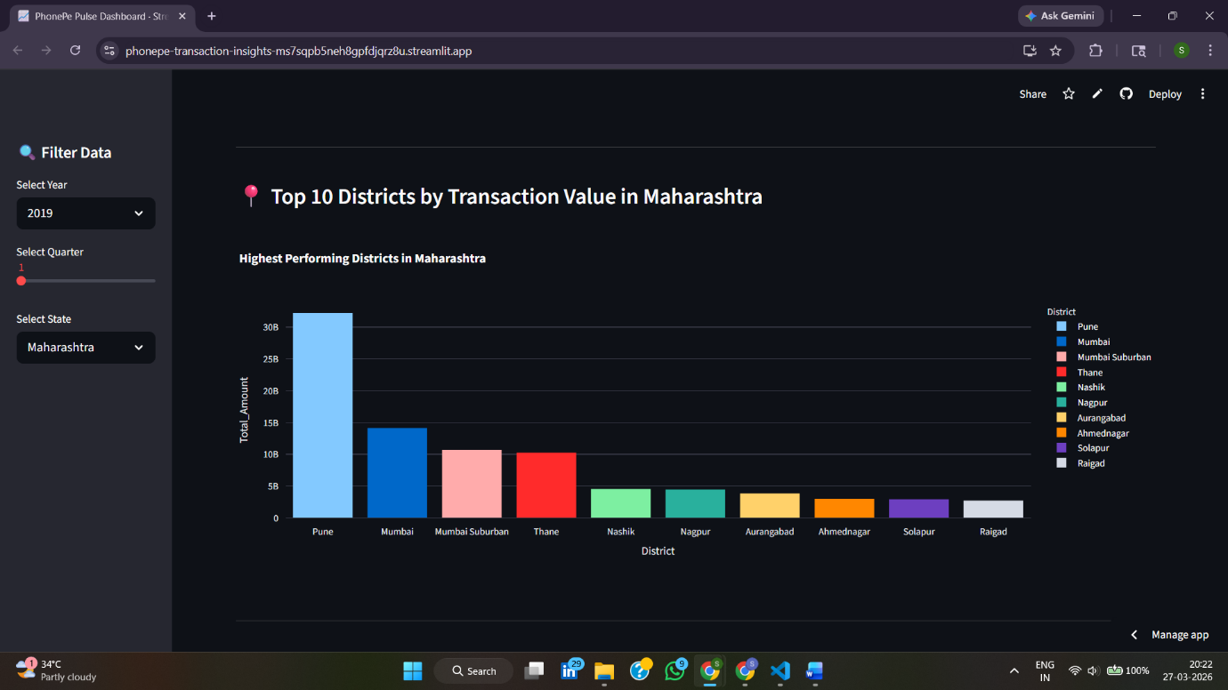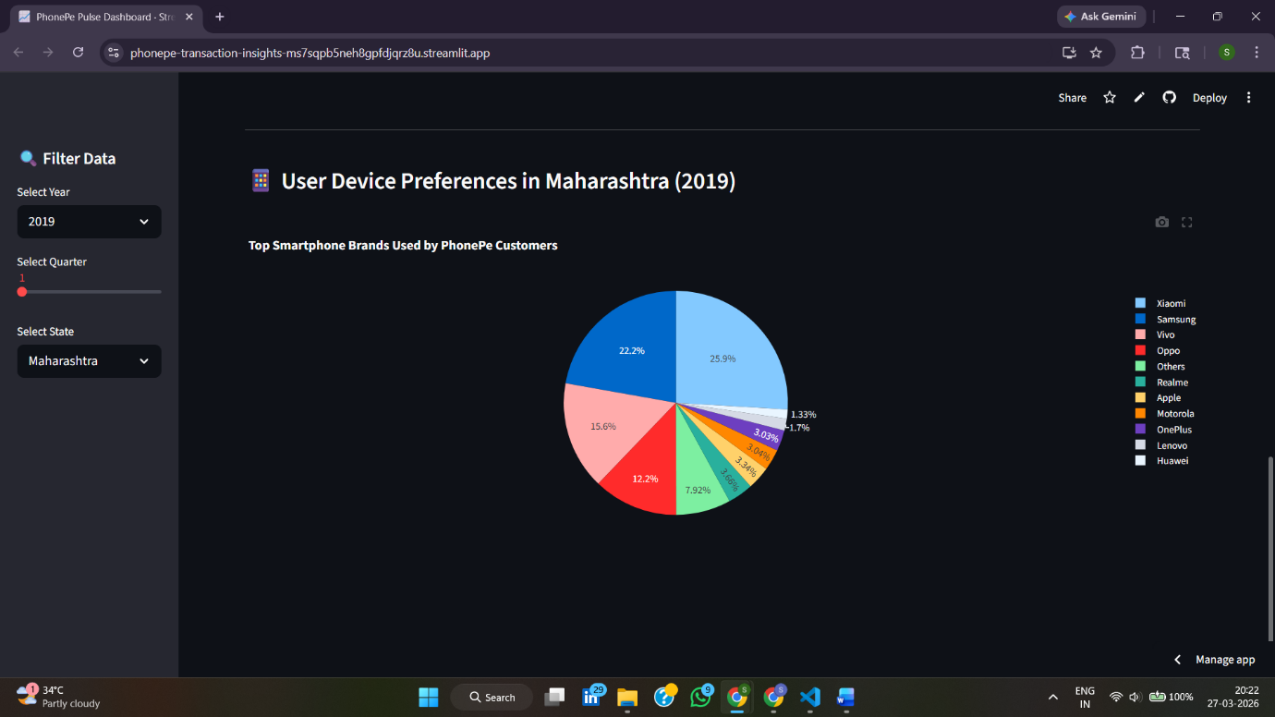

5: Conclusion
The PhonePe Transaction Insights project successfully built a robust ETL pipeline to extract, transform, and visualize massive volumes of PhonePe Pulse data through an interactive Streamlit dashboard.
Our Exploratory Data Analysis (EDA) revealed several critical market realities. While Peer-to-Peer (P2P) and Merchant payments overwhelmingly dominate transaction volumes, high-margin financial services remain significantly underutilized, presenting a major growth opportunity. Geographically, a stark digital divide exists: Tier-1 cities (like Bengaluru and Pune) and states like Maharashtra drive the vast majority of activity and insurance adoption, while rural districts lag far behind. Additionally, user engagement is heavily concentrated within the Android ecosystem, led by brands like Xiaomi, Samsung, and Vivo.
Moving forward, to maintain its competitive edge, PhonePe should leverage its massive P2P user base to cross-sell financial products, launch targeted awareness campaigns in underperforming rural areas, and prioritize Android app optimization. This data-driven approach and the scalable dashboard will ensure sustained growth and strategic market dominance.

